
University of Oregon
Indigenous Rights and Environmental Justice in Bolivia (6 credits)
OXFA 488/588, CRN 42683
Language of instruction: English
Professors Derrick Hindery, José Antonio Martinez Montaño and Zulma Villegas Gomez
Emails addresses: dhindery@uoregon.edu, jomartinez.zul@gmail.com, zulmavillegas63@gmail.com
*All course materials, including readings, will be posted on the course webpage on Canvas: https://canvas.instructure.com/login/canvas

Note: Please don’t login at https://canvas.uoregon.edu since this is a study abroad course
Register as a “new user”, create a user name and password, and accept the invitation I send you.
Please bring digital (downloaded as you might not have internet access) or printed copies of the readings to Bolivia

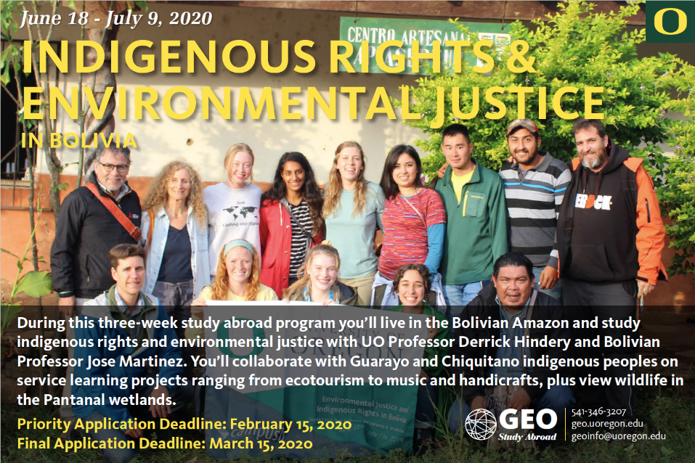

Course Description and Objectives

Welcome to Indigenous Rights and Environmental Justice in Bolivia! In this three week long faculty-led course in Bolivia you’ll live in indigenous communities located in two large-scale indigenous territories (Native Communal Territories, or TCOs) depicted by the green outlines in the map below:

- TCO Guarayos (7 days): Guarayo indigenous peoples, in the Bolivian Amazon
- TCO Lomerío (7 days): Chiquitano/Monkóxi indigenous peoples, in the Chiquitano Dry Forest, the largest remaining tall dry tropical forest in the world.

This course counts for six quarter credits and includes interactive lectures, discussions and experiential service learning. Students will study with University of Oregon Professor Dr. Derrick Hindery, Bolivian Professor José Antonio Martinez Montaño (Indigenous, Quechua), Bolivian scientist Zulma Villegas Gomez and indigenous representatives in a collaborative learning environment. All course activities will be conducted in English or translated to English.

You’ll view wildlife at the Pantanal Wetlands, the world’s largest wetlands, containing the highest concentration of fauna in New World, including jaguars, pumas, capybaras, giant anteaters, giant armadillos, endangered maned wolves and marsh deer as well as 656 species of birds and 263 species of fish. You’ll also stay in Santa Cruz city for 3 days, where we’ll visit World Wildlife Fund and/or PROBIOMA, a Bolivian non-profit that promotes sustainable agriculture and community ecotourism as well as Guembe Biocenter / water park which has one of the world’s largest butterfly sanctuaries, 15 natural pools, lagoons and an animal shelter. We’ll go on a tour of the city, have an interactive workshop with local non-profits, indigenous and Afro-Bolivian organizations, and conclude with a farewell dinner at El Aljibe, a traditional Bolivian restaurant.

You’ll carry out various service-learning projects prioritized by indigenous communities, such as:

- Website development
- Documentation and promotion of indigenous languages, culture, public health, music, foods, art and handicrafts (at women’s cooperatives) and history
- documentation of social and environmental impacts of extractive industries using GPS, GIS, multimedia, field data and satellite imagery (e.g. of climate change, deforestation, mining, roads and pipelines)
- environmental education (walking and biking, composting, sustainable agriculture, waste reduction)
- invasive species removal
- sustainable community building and conservation (e.g. conservation of biodiversity, sustainable community forestry, production of non-timber forest products (e.g. honey, medicinal plants, shade grown coffee, tea, nuts), agriculture (e.g. corn, cassava, plantain, beans, yams, peanuts, rice) and ecotourism)

Community activities in Guarayos include:

- Seminar with community chief and community members
- Handcraft workshop at the Urubichá women’s collective
- Community website/blog development
- Forest management activity
- Musical instruments production and rehearsals at the Urubichá Music Institute, renowned internationally for its mastery of indigenous/Baroque music playing and violin manufacturing.
- Recycling promotion and waste reduction
- Visit to neighboring communities

Activities in Lomerío include:

- Festival of San Juan Batista, celebrated nationally to coincide with Bolivia’s winter solstice and harvest season. This is a very traditional celebration, with typical food, dance and rituals.
- Seminar with community chief and community members
- Handicraft workshop at women’s cooperative
- Community website/blog development
- Seminars about forest conservation at local schools
- Recycling promotion and waste reduction

We will begin by exploring varying definitions of the term “indigenous,” analyzing social and political implications in relation to indigenous peoples’ access to and control over the environment. Given the importance of letting indigenous peoples “speak” for themselves as protagonists in environmental struggles, we will rely heavily on multimedia clips to ground the readings we do. This, of course, in addition to learning from indigenous peoples themselves throughout the course. Next, we will look at a range of lenses through which indigenous peoples view the environment, as well as paradigms through which external actors do the same, thinking about how such underlying assumptions affect how “environment” and “environmental issues” are framed and addressed. Following this introduction we will move on to a number of concrete contemporary topics, including self-determination and autonomy; indigenous peoples and climate justice; oil/gas/mining conflicts on indigenous territories; legal developments and challenges; natural resource management in indigenous territories (e.g. community-forestry); development encroachment (e.g. industrial farming and logging); conservation of biodiversity related to indigenous peoples’ intellectual property rights; and indigenous agroecology.

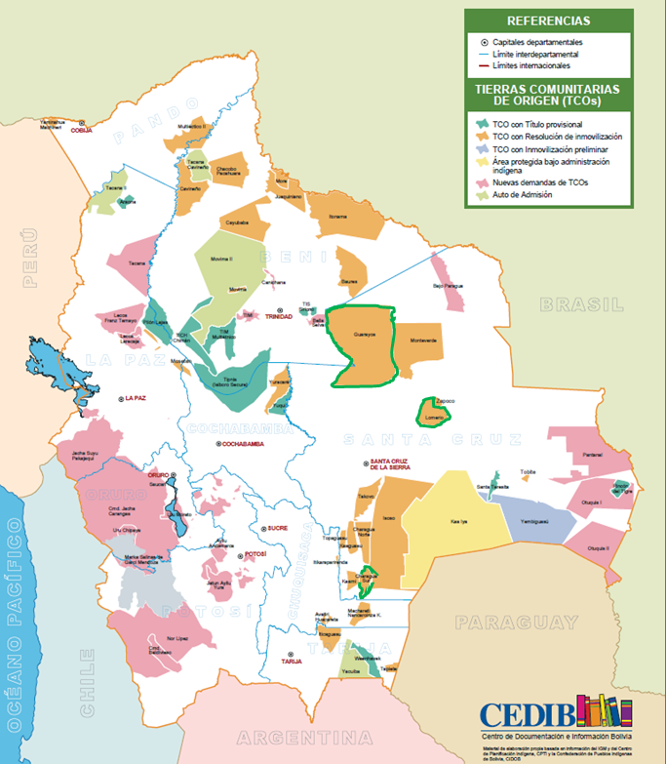

Map of Indigenous territories in Bolivia. The territories of Guarayos and Lomerio,
where we will stay, are depicted in green.

Learning Objectives: by the end of the term you should be able to:

- Understand respectful ways of collaborating with indigenous peoples
- Understand how indigenous knowledge is related to environmental conservation
- Understand how environmental justice, social justice and indigenous rights are intertwined
- Identify causal and dialectical relationships between economic development models, indigenous peoples and the environment
- Talk and write in an informed way about the topics covered in the course
- Have a better ability to think creatively, analytically, collaboratively and objectively

Faculty and Staff

Dr. Derrick Hindery is a geographer and Associate Professor in the Department of Global Studies at the University of Oregon. He has conducted collaborative research in Bolivia with Chiquitano/Monkóxi, Guarayo, Ayoreo and other indigenous peoples since the late 1990s on the effects of pipelines and mines built by multinational corporations (e.g. Enron and Shell) and financed by international financial institutions on indigenous communities and the environment. Professor Hindery is the author of From Enron to Evo: Pipeline Politics, Global Environmentalism, and Indigenous Rights in Bolivia. He has supported various community initiatives in Bolivian indigenous territories, including non-timber forest products (e.g. medicinal oils), ecotourism, handicrafts, music, environmental education, institutional strengthening and outreach. He previously worked at Amazon Watch, where he was involved with campaigns supporting indigenous peoples in Colombia (e.g. the U'wa in their struggles against Occidental Petroleum) and Ecuador (Chevron/Texaco).

José Antonio Martinez Montaño is a Bolivian Professor who has served as the head of Sociology at the Gabriel René Moreno Autonomous University (UAGRM) in Santa Cruz, Bolivia. A Quechua sociologist who conducts research on development, social movements, indigenous peoples, extractive industries and the environment, Martinez has served as a university professor at UAGRM since 1997. He is an associate investigator at the Center for Social Investigation in Support of Development (CISAD) and a member of the science committee. On a national level, he is a member of Bolivia’s Climate Justice Program. Martinez has published books and articles on forest management, deforestation, indigenous rights, indigenous history, impacts of fire on ecosystem biodiversity, protected areas and indigenous territories. He has taught courses on the anthropology of the Amazon, Chaco and Eastern Lowlands of Bolivia; Evaluation of Social and Environmental Impacts; Political Sociology; Research Methods and Techniques and Community Forestry. He worked with the territorial planning office (CPTI) at the lowland national indigenous organization (CIDOB), heading up the satellite imagery and Geographic Information Systems unit, produced an Atlas of indigenous territories in Bolivia and worked with indigenous peoples to map and insist the government create various large-scale indigenous territories in the country.

Zulma Villegas Gomez is a scientist whose passion for science and technology led her to study computer science at the Universidad Mayor de San Simón (Higher University of San Simón), located in Cochabamba, Bolivia, but her inclination towards people encouraged her to become a geographer, working with communities and the environment, particularly as a systems specialist of geographic information (GIS) and remote sensing. In recent years she has been involved in several research teams related to indigenous peoples, the environment and socio-environmental evaluation. Currently, her area of interest is the relationship between the environment and society, focused mainly on deforestation processes in Bolivia. She has collaborated with two important research centers: the Noel Kempff Mercado Natural History Museum (MHNNKM-UAGRM) as Head of the Geography and Informatics Laboratory, and the Center for Planning of Indigenous Territories (CPTI) within the Confederation of Indigenous Peoples of the Bolivia (CIDOB).

Schedule and Readings

You are expected to have done the readings before we discuss them. As I mentioned previously, all course materials, including readings, will be posted on the course webpage on Canvas (https://canvas.instructure.com/login/canvas). Please don’t login at https://canvas.uoregon.edu since this is a study abroad course. Register as a “new user”, create a user name and password, and accept the invitation I send you. Please bring digital or printed copies of the readings to Bolivia.

Tentative schedule:
June 19 – Orientation Session @ Casa Kolping meeting room; travel to Lomerio
June 20 – Orientations about Lomerio and introductions to the community
June 21 – Class 1: Lomerio readings (TOPIC 1)
-Maria Pomes Lorences, on Indigenous Autonomy and Gender in Bolivia and Lomerio, pp. 1-10, 110-24 (and as an option, read as much as you can of the rest, though not required)
-Chiquitanos: entry (2 pages)
-Chiquitanos, by Nancy Flowers (3 pages)
-El Camino Hacia la Libertad (English version online, University of East Anglia et al, Anacleto Pena et al), a great history written by Monkóxi
-Estudio de caso Nº 3 Lomerío, el sueño de un gobierno propio: territorio Chiquitano en Santa Cruz, by Alcides Vadillo
June 22 – Class 2: Thinking critically about study abroad and service learning (TOPIC 2)
-Bani Amor Are we doing vacations wrong? YES magazine
-Nordmeyer et al, Ending white saviorism in study abroad
-AAG Indigenous Peoples Specialty Group’s Declaration of Key Questions about Research Ethics with Indigenous Communities
June 23 – Class 3: Environmental Justice in Bolivia: case study of Chiquitanos (TOPIC 3)
-San Juan celebration in Monterito (near San Lorenzo)
-Mickelson, K., 'Critical Approaches', in D. Bodansky et al. (eds), Oxford Handbook of International Environmental Law, Oxford: OUP, 262–90
-Hindery, Chapter 6: “Struggling for Environmental Justice” in From Enron to Evo: Pipeline Politics, Global Environmentalism and Indigenous Rights in Bolivia
June 24 – Class 4: Hydrocarbon conflicts in the Chiquitano Region (TOPIC 4)
-Hindery, Chapter 9: “Cuiaba Under Morales” in From Enron to Evo: Pipeline Politics, Global Environmentalism and Indigenous Rights in Bolivia
June 25 – Class 5: continued
June 26 – Class 6: Deforestation & other environmental changes in the Bolivian lowlands (TOPIC 5)
Amazon Deforestation Once Tamed Comes Roaring Back,
June 27 – Pantanal Wetlands
June 28 – Pantanal Wetlands
June 29 – Pantanal Wetlands
June 30 – Orientations about Urubichá and introductions to the community
Class 7 Urubichá readings (TOPIC 6)
-Jesuit Legacy in the Bolivian Jungle: A Love of Baroque Music, by Nicholas Casey
-Communal Tenure Policy and the Struggle for Forest Lands in the Bolivian Amazon
Peter Cronkleton, Pablo Pacheco (pages 9-18, but please at least skim the rest)
-Larson and Cronkleton, Formalizing indigenous commons: The role of ‘authority’ in the formation of territories in Nicaragua, Bolivia and the Philippines (pages 11-12 (not 9-10) and skim the rest)
July 1 – Class 8 continued
July 2 – Class 9 Autonomy more broadly in Bolivia (TOPIC 7)
-Chapter 7 on Indigenous autonomy in Charagua, Bolivia, in Postero, N. The Indigenous State: Race, Politics, and Performance in Plurinational Bolivia. California: University of California Press. DOI: https://doi.org/10.1525/luminos.31
-Jason Tockman, John Cameron & Wilfredo Plata. New Institutions of Indigenous Self-Governance in Bolivia: Between Autonomy and Self-Discipline, Latin American and
Caribbean Ethnic Studies, 10:1, 37-59, DOI: 10.1080/17442222.2015.1034442
July 3 – Class 10 continued
July 4 – Class 11 Natural resource struggle and indigenous rights in Bolivia (TOPIC 8)
-Jose Martinez guest lecture
-Susana Rivero Guzmán, The struggle for natural resources and for the rights of indigenous peoples: From exclusion and plunder to return of the land, Indigenous Affairs, (read all, but focus on pp. 31-35)
July 5 – Class 12 Climate Justice in Bolivia (TOPIC 9)
Fabricant, Nicole “Good Living for Whom? Bolivia’s Climate Justice Movement and the Limitations of Indigenous Cosmovisions.” Latin American and Caribbean Ethnic Studies 8 (2): 159–78. doi:10.1080/17442222.2013.805618.
July 6 – Class 13 (final class) Agroecology (TOPIC 10)
-Altieri et al. Agroecologically efficient agricultural systems for smallholder farmers: contributions to food sovereignty
-Robin Wall Kimmerer. Weaving Traditional Ecological Knowledge into Biological Education: A Call to Action
July 7 – Excursion to WWF, PROBIOMA, Colloquium in Santa Cruz (2:30pm-5) at CIPCA with local organizations (CIPCA, CEJIS, local indigenous leaders)
July 8 – Excursion to Guembe
July 9 – Departure day

Course Requirements and Grading:

The success of this course depends on your attendance and participation. The following is the breakdown for your course grade:

20% Attendance and participation
20% Summary and analysis of readings based on 1 or more reading per topic. See below for details (credit / no credit). Due August 15, though ideally you’d complete them by the time each topic is covered.
20% Discussion leadership described below
40% Service learning paper academic paper that weaves together the service learning you did with academic and non-academic literature. Due August 15. A detailed description will be posted on the course website.

Grading Scale

Numerical Grade | Letter Grade
≥ 97.5 | A+
≥ 92.5 | A
≥ 90.0 | A-
≥ 87.5 | B+
≥ 82.5 | B
≥ 80.0 | B-
≥ 77.5 | C+
≥ 72.5 | C
≥ 70.0 | C-
≥ 67.5 | D+
≥ 62.5 | D
≥ 60.0 | D-
< 60.0 | E

Statement on Grades

A+ Quality of student’s performance significantly exceeds all requirements and expectations required for an A grade. Very few, if any, students receive this grade.
A: Quality of performance is outstanding relative to that required to meet course requirements; demonstrates mastery of course content at the highest level.
B: Quality of performance is significantly above that required to meet course requirements; demonstrates mastery of course content at a high level.
C: Quality of performance meets the course requirements in every respect; demonstrates adequate understanding of course content.
D: Quality of performance is at the minimal level necessary to pass the course, but does not fully meet the course requirements; demonstrates a marginal understanding of course content.
F: Quality of performance in the course is unacceptable and does not meet the course requirements; demonstrates an inadequate understanding of course content.

Since we will be discussing the readings each time we meet, you will need to have done them prior to class. This will work to your own benefit, because you’ll learn more from the class, and you’ll spread out your workload throughout the program, thereby avoiding “surprises.” Please focus on major concepts. You might skim each reading rapidly, extract the major points, and then read the piece more carefully with the major points in mind. The class suffers if you’re not prepared and don’t participate to your fullest. In addition, you’ll understand lectures and discussions better.

In addition to the required readings, I encourage you to keep informed of current affairs so as to further ground the knowledge you gain through this class. Throughout the course, please feel free to express your ideas and enter into dialogue with myself and your fellow students. Although I do not want to discourage you from expressing your view, I expect that you will be courteous to others, respect different views, and refrain from personal attacks. Through this dialogue, you will encounter perspectives that are different from your own, which will enable you to explore new ideas, challenge your own assumptions, and develop a well-informed position. As a result of such discussion and assignments, you will improve your critical thinking and writing skills--tools that you will carry with you beyond this class.

I also encourage you to meet with me to discuss anything related to the class, whether you wish to discuss logistical issues such as grading or conceptual issues related to lecture and readings. ***You must meet with me by the end of our time in Bolivia to finalize a topic for your research paper. You will define your topic together with indigenous representatives. (Please come prepared having done preliminary research. Please be sure to bring a hardcopy or upload a rough outline of your paper to Canvas, with a list of five academic sources you’ve perused before we meet.)

I look forward to working with all of you throughout the course, and encourage you to give me feedback at any time. I will do my best to incorporate your suggestions.

Written responses:

Written responses are due August 15, though ideally you’d complete them by the time each topic is covered. Either way, please bring summary notes to class for discussion, along with criticisms and two or three discussion questions. The idea is to have you read the readings before we discuss them. Please upload electronic copies to Canvas and bring printed or electronic copies to class (if you decide to finish them before class, though you have until August 15). Label the file name according the topic # of the response, e.g. “Topic 2 Response” Please upload the response as pasted text rather than as an attachment. Formatting is not critical, just content. Undergraduate students may take up to a maximum of 1 pages, if necessary, and a minimum of 300 words (2 pages and 600 words for graduate students). For each topic choose at least one of the topic’s readings for your response. This does not imply that you are to gloss over readings you don’t choose, but simply gives you a chance to focus on two. During the topic(s) for which you are a discussion leader (described below) you do not need to submit individual responses, but rather your groups’ talking points, critical reflections, and discussion questions. Please use the following structure for your responses:

- First section: Summary

Simply write a short summary of the key points raised in the readings you selected. Don’t get lost in the details. Think big picture. This can be essay format or in understandable bullet points.

- Second section: Critical analysis and your own assumptions

Critically analyze the readings. The easiest way to do this is to re-read what you wrote for the summary, and then ask your self whether or not you agree with arguments put forth, and why. Base your analysis on facts. Consider the authors’ deeper, underlying assumptions. These are usually unstated, and implicit. A good way of getting at these deeper assumptions is by figuring out the author(s)’ approach, or paradigm. Include a sentence describing your own underlying (deeper) assumptions. As with the summary paragraph, this can be essay format or in understandable bullet points.

Discussion Leadership:

Each class two or three of you will lead discussion, helping us identify key points from the readings, critical reflections, and points of discussion. Please prepare some brief slides (using PowerPoint or the like) listing summary points, criticisms and overarching discussion questions. In keeping with the spirit of hearing from indigenous community members and representatives, please find one or more audio or video clip(s) for your topic too. Simply bring your files on a USB jump drive, and email them to yourself as a backup. Naturally, this is an important backbone of the course, so please dedicate your full energy to it. We’ll assign times during which you will serve as leaders during the first class meeting. Even when you’re not a discussion leader please bring notes from the readings so you can refer to them.

Course Policies:

- Course Expectations: As mentioned, I expect each of you to do assigned readings before class, and turn in all assignments on time.
- Attendance Policy: I expect you to attend class regularly and participate in the class discussion. If you miss a class it is your responsibility to obtain notes from a fellow student. Credit for missed classes will only be granted if documented and if you do an additional write-up on a reading of your choice for the topic of that day.
- Academic Integrity: Cheating and plagiarism will not be tolerated. You may check the University Catalog and/or the Schedule of Classes for definitions and examples of, and penalties for academic dishonesty. Plagiarism software provided by the University of Oregon will be used to ensure compliance.
- Due Dates/Make Up Work: Make-ups will be allowed only if you have contacted me before the scheduled date, with a documented serious excuse.

Required Materials:

- All readings will be posted to the course website on Canvas, noted previously

Accessible Education:
The University of Oregon is working to create inclusive learning environments. Please notify me if there are aspects of the instruction or design of this course that result in disability-related barriers to your participation. You are also encouraged to contact the Accessible Education Center in 360 Oregon Hall at 541-346-1155 or uoaec@uoregon.edu.

Academic Misconduct
The University Student Conduct Code (available at conduct.uoregon.edu) defines academic misconduct. Students are prohibited from committing or attempting to commit any act that constitutes academic misconduct. By way of example, students should not give or receive (or attempt to give or receive) unauthorized help on assignments or examinations without express permission from the instructor. Students should properly acknowledge and document all sources of information (e.g. quotations, paraphrases, ideas) and use only the sources and resources authorized by the instructor. If there is any question about whether an act constitutes academic misconduct, it is the students’ obligation to clarify the question with the instructor before committing or attempting to commit the act. Additional information about a common form of academic misconduct, plagiarism, is available at researchguides.uoregon.edu/citing-plagiarism.

Reporting Obligations:
I am a student-directed employee. For information about my reporting obligations as an employee, please see Employee Reporting Obligations on the Office of Investigations and Civil Rights Compliance (OICRC) website. Students experiencing any form of prohibited discrimination or harassment, including sex or gender-based violence, may seek information and resources at safe.uoregon.edu, respect.uoregon.edu, or investigations.uoregon.edu or contact the non-confidential Title IX office/Office of Civil Rights Compliance (541-346-3123), or Dean of Students offices (541-346-3216), or call the 24-7 hotline 541-346-SAFE for help. I am also a mandatory reporter of child abuse. Please find more information at Mandatory Reporting of Child Abuse and Neglect.”

Additional Resources
Also, always feel free to meet with me if you need additional help. That said, I do expect that you attempt to learn the material on your own first and come prepared.

Below, I have pasted a number of online resources to help you keep informed. Beyond this, I encourage you to peruse the library’s physical and online holdings related to the course. In addition there are also some excellent multimedia resources available at the Library as well (online as well as physical videos, DVDs, and CDs).

SUBMITTING THE RESEARCH PAPER:
Please save paper and upload it to Canvas by August 15.

Online Resources

University of Oregon guide to Global Studies resources (subject dictionaries and encyclopedias; yearbooks; directories of organizations; finding articles; finding books and government publications; statistics; news and analysis; web resources):
http://libweb.uoregon.edu/guides/intlstudies/general.html

Bolivian organizations:

CEDIB: documentation center (documents, video, audio) regarding indigenous peoples and many topics in Bolivia: www.cedib.org/
CEJIS: a legal organization that supports indigenous peoples and small-scale farmers in Bolivia: http://cejis.org/
CIPCA: conducts research and supports indigenous peoples and small-scale farmers in Bolivia: http://www.cipca.org.bo/
DIAKONIA: funds indigenous, Afro-Bolivian and women’s’ organizations in Bolivia, and generally supports underrepresented populations: http://www.diakonia.se/en/Where-we-work/Latin-America/Bolivia/
Fundación Tierra: supports indigenous peoples and underrepresented populations struggling for land tenure in Bolivia: www.ftierra.org/

Indigenous / environment links:

Indigenous Environment Network: http://www.ienearth.org/nativeenergy.html
International Work Group for Indigenous Affairs: http://www.iwgia.org

International News

-You’re probably familiar with mainstream media outlets, such as the New York Times or BBC. Here are a few others:
The Ecologist: www.ecologist.org (provides broad analysis on politics and economics, as well as social and environmental issues worldwide)
Manchester Guardian Weekly (international news): http://www.guardian.co.uk/
National Public Radio: www.npr.org
The Nation: www.thenation.com
Common Dreams News center: http://www.commondreams.org/
IRC Americas Program http://americas.irc-online.org
World News Network: http://www.wn.com/

Directories of non-governmental organizations (NGOs), and a couple environmental NGOs working with indigenous peoples

http://www.wango.org/resources.aspx?section=ngodir
http://www.google.com/Top/Society/Organizations/Development/
Amazon Watch: www.amazonwatch.org
Pacific Environment: www.pacificenvironment.org
Mapuche (Chilean indigenous group) international link: http://www.mapuche-nation.org/english/frontpage.htm

Technical Resources

EPA Environmental Justice Mapping Tool http://www.epa.gov/enviro/ej/
EPA - Envirofacts Multidatabases http://www.epa.gov/enviro/index_java.html

